***Experiment 2***

**Aim:** Students will design and implement a star schema data model for a given business scenario, focusing on creating fact and dimension tables.

***Creating Tables***

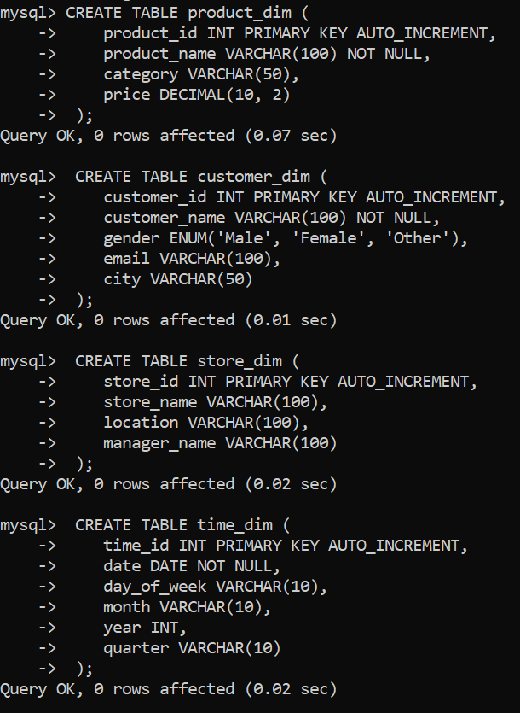

***Creating Database and Using in MySQL***

***Creating Tables***

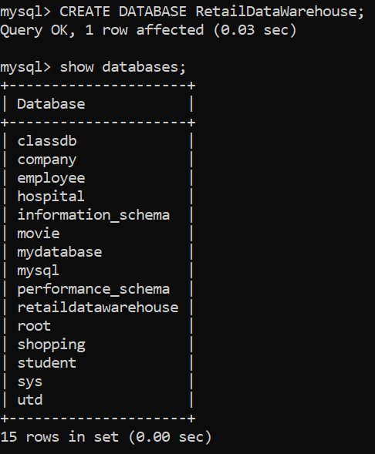

***Fig 2: Creating Tables with datatypes***

***Fig 1: Database in MySQL***

***Inserting Data***

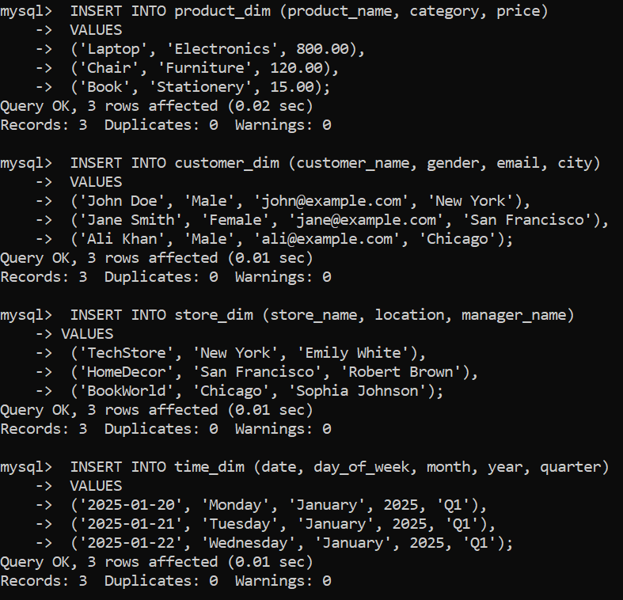

***Aggregate Queries***

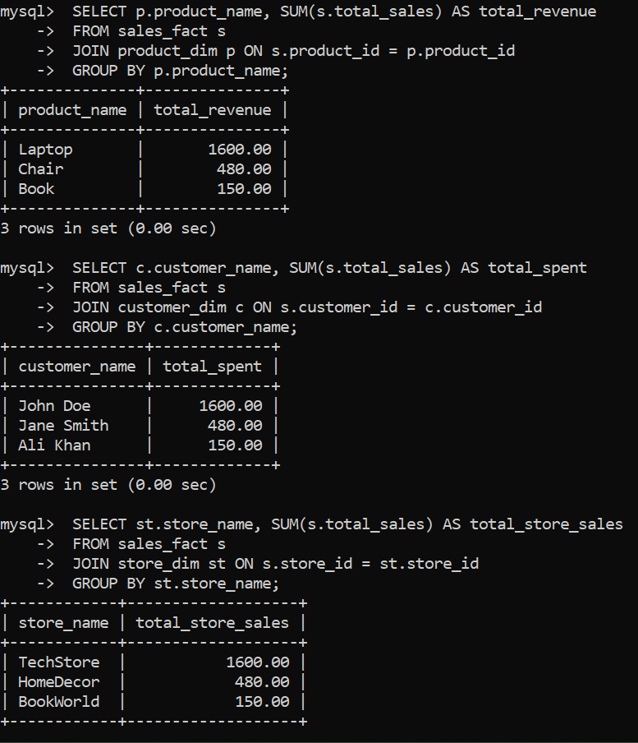

***Fig 3: Inserting data into tables***

***Fig 4: Aggregate Queries in tables***